Electromagnetic Induction

Name: ____________________________

Download and run the simulation “Faraday’s Electromagnetic Lab”:
https://phet.colorado.edu/en/simulation/legacy/faraday
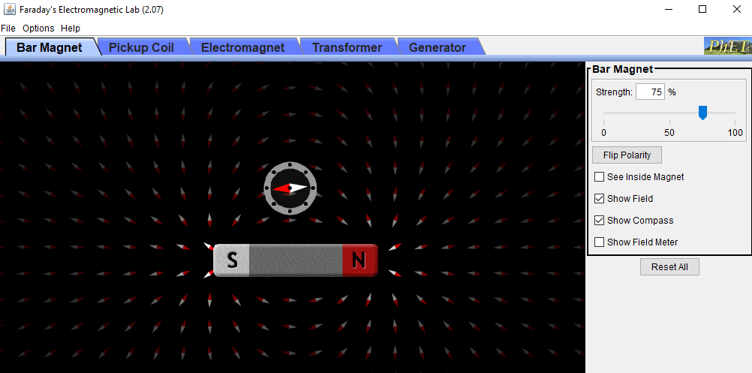
Step 1: Notice the magnetic field lines, how they originate from the north pole and end on the south pole. Drag the compass around at difference places near the magnet and notice the direction of the magnetic field there. Click on flip polarity and notice how the magnetic field lines change direction when north pole becomes south and vice versa.
Step 2: Move the compass to a side away from the bar magnet. Check the box next to “Show Field Meter”. A magnetic field sensor will appear, displaying the average magnetic field B at that particular point where it is placed, along with the horizontal and vertical components Bx and Bx as well as the direction of the field vector relative to the bar magnet.
Step 3: Drag the Field Meter with its cross hair at point A shown in the picture below. Record the magnetic field along with direction at this point, writing all values in the table on the next page.
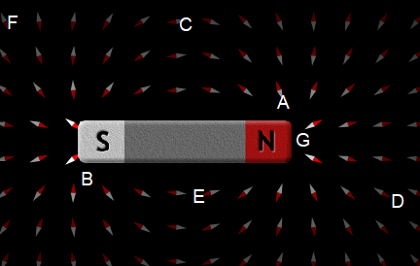
Step 4: Repeat Step 3 for points B, C, D, E, F, and G.
Point | $$B$$  (G) | Bx  (G) | By  (G) | θ  (Degrees)
A | 9.79 | -2.16 | 9.55 | 102.75
B | 20.60 | -2.98 | 20.38 | 98.32
C | 1.43 | -1.43 | 0.07 | 177.21
D | 1.53 | 1.28 | -0.83 | -32.83
E | 3.11 | -3.11 | -0.15 | -177.23
F | 1.43 | 0.69 | -1.25 | -61.20
G | 50.91 | 50.62 | 5.47 | 6.16

Based on your data table, where is the magnetic field strongest?
Your answer: G

Based on your data table, where is the magnetic field weakest?
Yours answer: F

Step 5: Click on the tab “Electromagnet” on the menu bar on top of the simulation. You will see that a coil is connected to a battery, and as the current passes through the coil, there is magnetic field produced near the coil. Inside the coil the magnetic field is almost constant and parallel to the axis of the coil.
Step 6: Check the “Show Field Meter” box. Place the Field Meter somewhere near the coil. Slowly decrease the battery voltage by sliding the horizontal bar on the battery. Notice that as the current decreases the magnetic field also decreases in strength.
What happens to the magnetic field when you reverse the direction of current by sliding the battery voltage bar past 0 volts.
Your answer:
The magnetic field increases.
Step 7: Keeping the Field Meter at the same place, click on the AC under the Current Source menus.
What kind of magnetic field do you see now? Why is it constantly changing?
Your answer:
AC magnetic field.
AC current is time varying current in form of a sine wave, therefore the resultant magnetic field is also time varying hence the reason why it’s constantly changing.
Step 8: Click on the tab “Pickup Coil” on the menu bar on top of the simulation. You will see that a coil is connected to a light bulb without any battery in the circuit, and the light bulb is off. Drag the bar magnet and slowly move it through the coil, you will notice that bulb light up while you are moving the magnet and stops lighting when you stop the magnet or if the magnet is far away from the coil. Keep the magnet fixed at one place and move the coil such that coil goes over the magnet and notice that the light bulb again lights up. So, it does not matter if you move the magnet or the coil, in both cases you are producing electricity. All of our modern electricity production industry is based on this simple principle that when a magnet moves near coil (or vice versa), it produces electricity in the coil. This is called Faraday’s law of electromagnetic induction, discovered independently by Michael Faraday in 1831 and Joseph Henry in 1832.
Now move the magnet faster and notice the brightness of the light bulb.
Does the brightness increase or decrease?
Your answer:
It increases
Step 9: Under the Pickup Coil menu, click on the “Voltage Indicator” 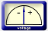 and set the number of loops to 1. Now move the magnet through the single loop coil as fast as you can a few times and notice how high the Voltage indicator goes. Change the number of loops to 2, and again move the magnet as fast as you can, looking at the Voltage Indicator. Repeat this process with 3 loops too.
Does the voltage (or emf) induced increase or decrease with more number of loops?
Your answer:
The voltage induced increases.

Step 10: Keeping the number of loops fixed, increase and decrease the area of the coil using the horizontal bar under the Pickup Coil” menu.
Does the induced emf or voltage increase or decrease when you decrease the area of the coil?
Your answer:
The induced emf decreases.

Step 11: Remember that in Step 5 we found out that when electric current runs through a coil, the coil becomes a magnet, and we studied it magnetic field. That means that if current runs through a coil, we can move it near another coil and induce a current in the secondary coil (the apnea monitors used in the hospitals to monitor patient breathing patterns work on this principal and essentially consist of two coils).
Let’s test this idea. Click on the tab “Transformer” on the menu bar on top of the simulation. Move the coil connected to the battery near the coil connected to the light bulb quickly and you will notice that the bulb lights up, so emf is indeed induced as we expected. Instead of moving the coil connected to the battery you can move the coil connected to the light too, and you will get the same induced emf.
Step 12: Now bring the coil connected to the battery and place it close to the other coil connected to the light bulb. Once you leave it there you will notice that the bulb is not lit up anymore. Of course, you are not doing the work, hence there is not voltage induced. You have to continuously do the work to get the induced voltage. Why? Because you can include the voltage only by changing magnetic flux, you need to move the magnet to achieve that.
Step 13: Keeping the coils where they were in Step 12 (light bulb off), click on AC under the Current Source menu to run the AC current through the coil that was initially connected to a DC battery. Notice that the light bulb now continuously turns on and off, so voltage is induced but it is AC, it goes to a maximum and a minimum. You can see that the magnetic field is continuously changing not only in magnitude but also it flips its direction, so the magnetic flux is continuously changing. If you increase the number of loops in the coil that is connected to the light bulb, you would observe that the light bulb gets brighter, so more voltage is induced. That is how transformers work, if you want mor voltage you would increase the number of loops of the secondary coil.
How would explain the fact that now you are not doing any work and still a voltage is induced? Who is doing the work now?
Your answer:
A steady AC current creates a steady magnetic field the resultant time-varying magnetic field induces a voltage in a nearby conductor.
The constantly changing magnetic field does the work.

Step 14: Now that we know that moving a magnet near a coil induces a voltage in the coil, but the moment you stop moving the magnet the induced voltage drops to zero. You may ask that how do we produce electricity then, that keeps running all electric devices at our homes and office all the time. The answer is we use an electric generator that utilizes the Faraday’s law of electromagnetic induction.
Let’s look at an electric generator now. Click on the tab “Generator” on the menu bar on top of the simulation. Under the Pickup Coil menu, click on the “Voltage Indicator” and set the number of loops to 1. Turn on the water tap by slowly sliding the horizontal bar on the faucet. As the water fall down onto the wheel, it starts rotating, the magnet attached to the wheel also rotates, that changing magnetic flux through the coil placed next to it, inducing an emf in the coil.
Try all the different settings in this simulation and find out at least 4 different variables that increase the induced voltage:
Your answer:
- Increase in the speed of water.
- Increase in revolutions per minute of the coil.
- Increase in the number of loops in the coil.
- Increase in magnetic flux.

